**Topic: Embedded IoT with Edge Computing**

1. Pushing factors of emerging technologies

Source: (https://www.automatedbuildings.com/news/nov19/articles/cctrls/191029104707cctrls.html)

According to International Business Machine (IBM), edge computing is “an important emerging paradigm that can expand your operating model by virtualizing your cloud beyond a data center or cloud computing center. Edge computing moves application workloads from a centralized location to remote locations.”

The main pushing factors for embedded IoT with edge computing are:

1. Due to the advancement of embedded hardware performance.

- Some of the example of edge computing hardware are Raspberry Pi, NVDIA Jetson Nano, BeagleBone Black, and Khadas Edge-V.

1. The rise of cloud computing and IoT.

* More devices accessing cloud services are using IoT appliance that can transmit data online for processing and analyzing in the cloud. But the problem arises when the increasing volume of data the need to be transmitted which make centralized processing become problematic.
* Some of the issues on cloud computing is high data transmissions. Thus, it poses burden on available network capacity which indirectly causes latency that resulting in slow speed response
* Examples of connecting IoT appliances are cameras, HVAC equipment, process automation equipment, smart homes, smart factories and smart cities.

1. Connection issues in IoT applications

* (source: <https://www.eurotech.com/en/news/edge-computing-embedded-iot>)
* The mission-critical applications always need to be monitored and generate large data flows to send to cloud.
* So, there might be some connection issues will be faced during transmitting the data.

Hence, the edge computing offers devices that will rely on the cloud entirely by processing some of their own data locally. As an example, is a networked camera. Instead of sending data it had captured to the cloud, waiting on the data to be processed in the cloud, and receiving the processed response back from the cloud. A networked camera may now perform local data processing for visual recognition and respond accordingly

1. Issues

Source: <https://ww2.frost.com/frost-perspectives/challenges-of-adopting-edge-computing/>

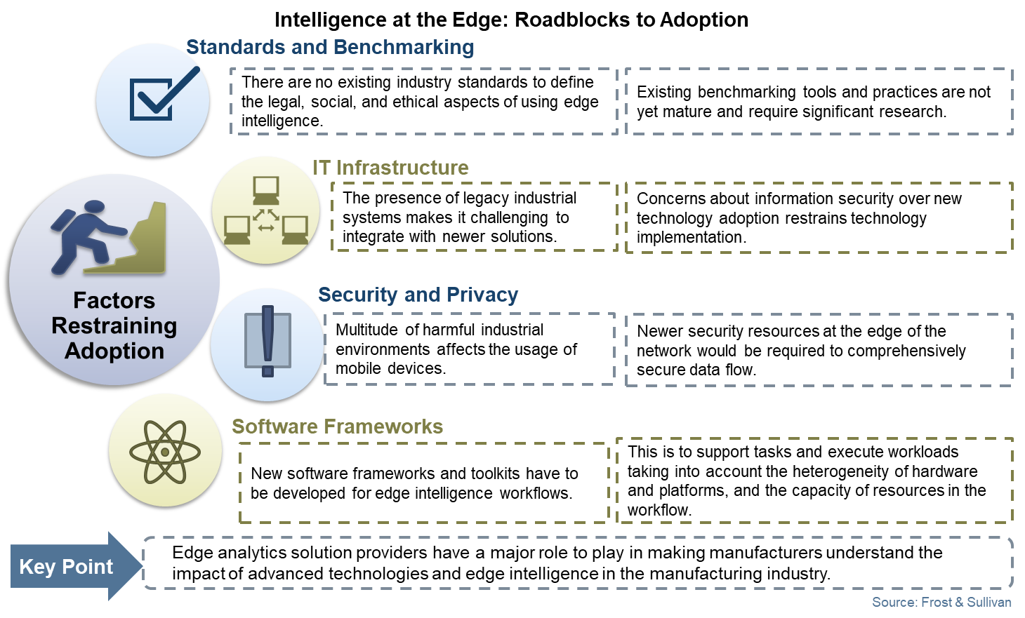

* Standards

There are no existing industry standards to define law, social, and ethical aspects for edge computing. The existing benchmarks are still not mature yet.

* Infrastructure
* There might be the presence of industrial systems which makes it more challenging to adapt with newer solutions.
* R&D in edge enabled software frameworks and hardware devices must be assisted by substantial capital investment, which will certainly raise the initial costs of edge computing. This investment is required to support tasks and execute workloads.
* Security

Edge devices are generally small, cheap and not designed with security in mind. For ease of use, a majority of these devices don’t mandate any authentication with third-party APIs. To save costs and speed up deployment, a lot of them don’t encrypt data natively.

* Software frameworks
  + The edge intelligence workflows need to be developed when we have new software frameworks and toolkits.
  + This is because to support tasks and execute workloads and capacity resources in the workflow